Since there was two players with 9 game hitting streaks, Miguel Cabrera and Cedric Mullins, I decided to run a clump test on both players.
Miguel Cabrera
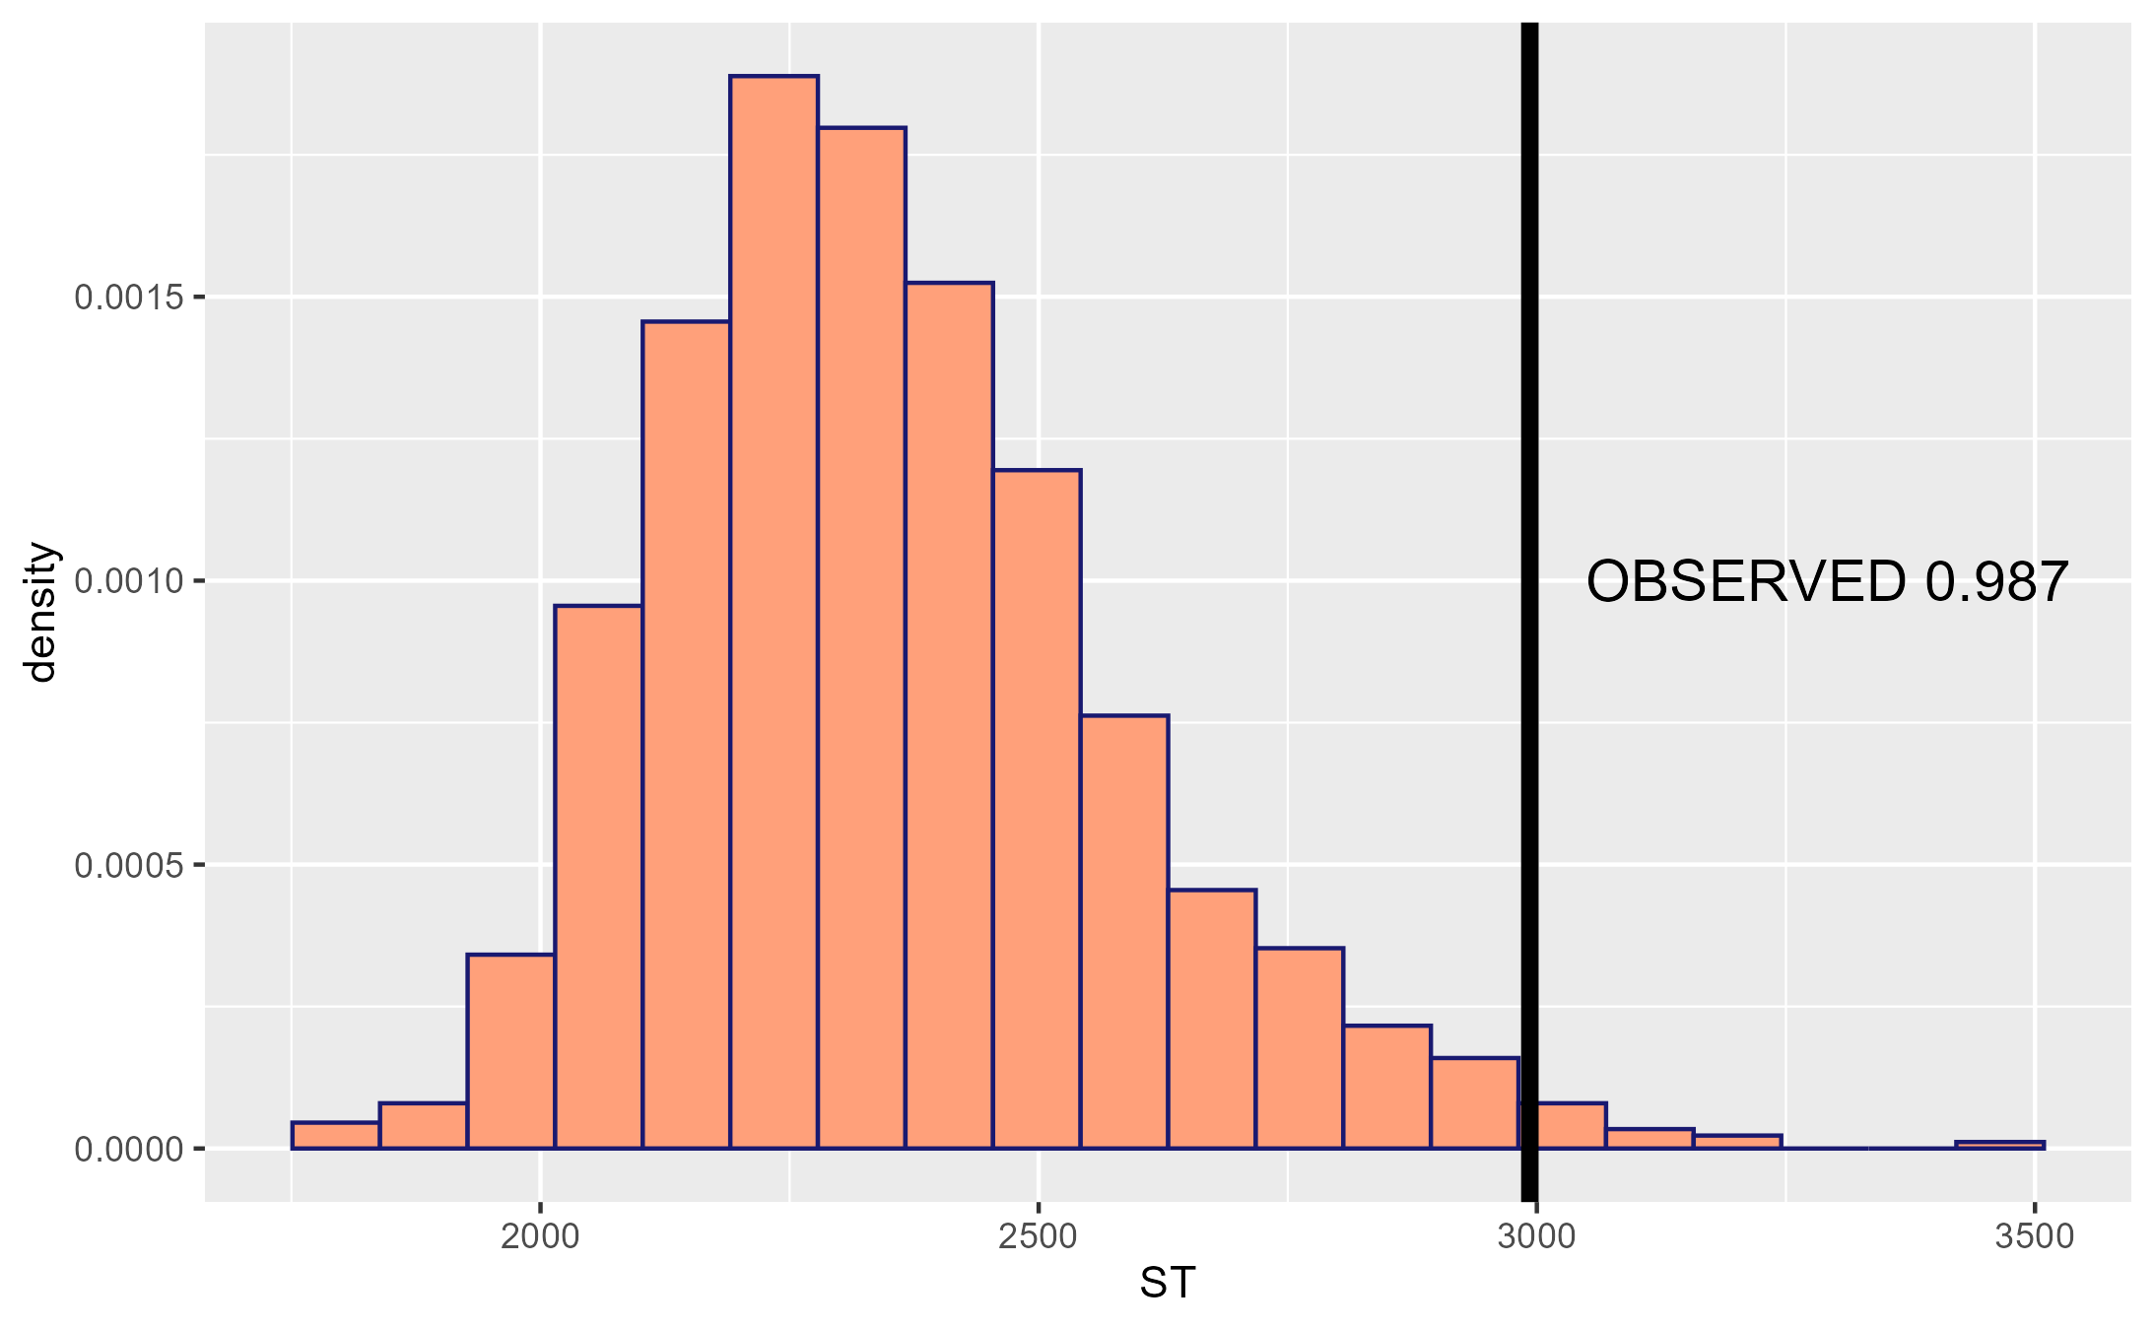
Based on this chart we see that Miguel Cabrera’s streakiness stat is 0.987. There is a 0.13% chance that a random model would produce a value of 0.987 or higher. This provides evidence that Miguel Cabrera was streaky during the 2021 MLB season.
Cedric Mullins
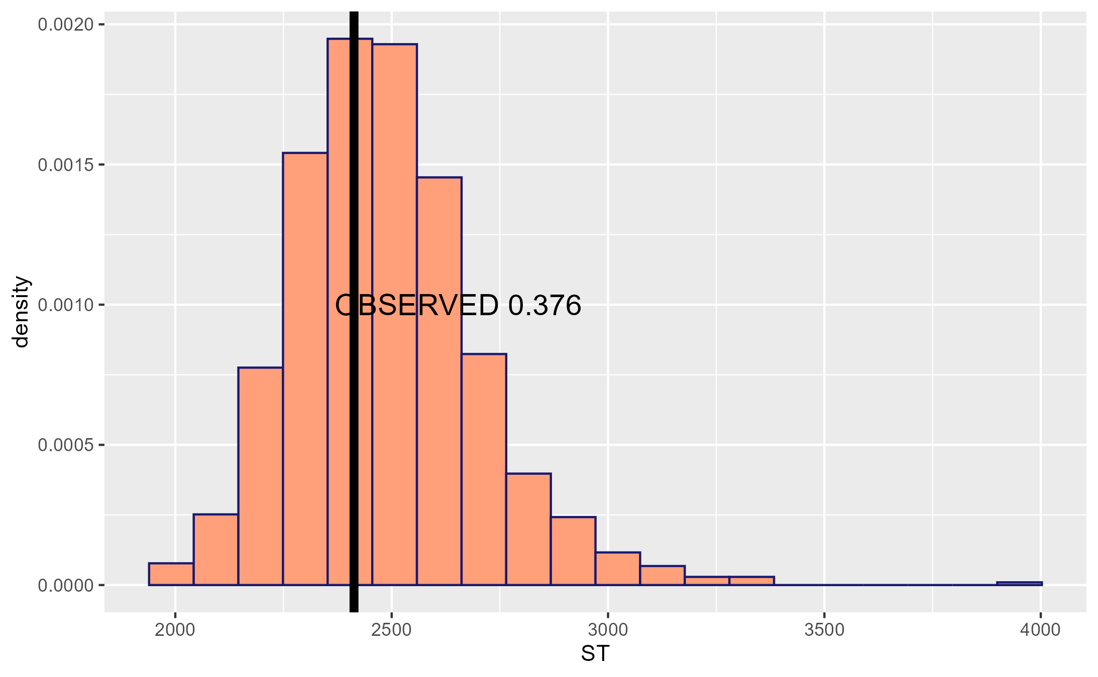
For Cedric Mullins we can see that his streakiness stat is 0.376 and is just about right in the middle of the histogram distribution. With the streakiness stat there is a 62.4% chance that a random model with yield a value that is the streakiness stat or higher. So we can say there is evidence that Cedric Mullins was not streaky during the 2021 MLB season

